

**INTERNSHIP REPORT**

**Spring 2021**

School of Engineering and Computer Science

An undergraduate internship report on Web Development

submitted by

Sayed Munshi

Id 1430748

Section: 01

Course ID: CSE 499

Instructor: Mohammad Noor Nabi Senior Lecturer

Department of Computer Science and Engineering

School of Engineering & Computer Science

Independent University, Bangladesh

**Acknowledgements**

Firstly, I want to thank Almighty Allah for everything for giving me the strength and opportunity to finish the report within the scheduled time.

I would like to thank the Independent University, Bangladesh (IUB) for offering an Internship program for me. A special gratitude I give to Mohammad Noor Nabi, whose contribution in stimulating suggestions and encouragement, helped me to coordinate my project especially in writing this report. The timely completion of this project is mainly due to the interest and dedication of the company. Along with that I need to thank Mithu, Director of HashKode for his Monitoring and guidance to fulfill my Internship. He provided me so many learning opportunities to enrich my knowledge.

Sayed Munshi February 2021

Dhaka, Bangladesh

**Letter of Transmittal**

Mohammad Noor Nabi

Senior Lecturer,

Independent University, Bangladesh

Subject: Submission of internship report on ‘Web-Based E-Commerce Application Development’

Dear Sir, It is my pleasure and great honor for me to submit my internship report titled “Web-Based E-Commerce Application Development in Bangladesh” authorized under your supervision, as a requirement for the completion of CSE-499 intern course. I have done my internship at HashKode, IT company as an Onsite Intern for three months (January 1 – April 18). I have tried to achieve the goal of this course. I have tried to follow all the instructions given to me by my supervisor and I am really thankful to you Sir, for your all kinds of support and helpful instructions during the Work and in the process of writing this report.

It will be a matter of great pleasure for me if the report can attain its objective and it will be great pleasure to me with any sort of suggestion from you regarding this report. Sincerely Yours

Sayed Munshi

ID - 1430748

Independent University, Bangladesh

**Abstract**

This report is divided into eight different chapters. At first in chapter one there is an introduction, background of designing, design objective. Then we go to Chapter two that describes the overview of Hashkode. Then Chapter three that focuses on Literature Review. Chapter four describes the requirement analysis. Chapter five focuses on development phases of web designing, e commerce development. Chapter six narrates responsive UI designing. Chapter seven describes conclusion and recommendation.

Table of Contents

Acknowledgements 1

Letter of Transmittal 2

Abstract 3

CHAPTER 1 4

Executive Summary 4

* 1. Objectives 5

General Objective 5

* 1. Specific Objective 5
  2. Scope of the report 5
  3. Methodology 6

Primary Sources 6

Secondary Sources 6

* 1. Limitation 6
  2. Arrangement of the report 6

CHAPTER 2 7

Literature review 8

CHAPTER 3 8

COMPANY PROFILE 9

* 1. Services 10

The vision of HashKode 10

* 1. Departments 11
  2. Roles and Responsibilities 12

3.4 Working Environment 13

CHAPTER 4 14

REQUIREMENTS 14

* 1. System Requirements: 14
  2. Functional Requirements: 15
  3. Non-Functional Requirements 17
  4. Performance Requirements: 18

CHAPTER 5 19

TOOLS & TECHNOLOGIES 19

* 1. Overview 19

5.1.1 Why React JS 19

* 1. Comparison 20
  2. Node Modules 21
  3. The language used for Web Development 22
  4. Editor: Visual Studio Code 22

CHAPTER 6 23

DEVELOPMENT PROCESS 23

* 1. Project Design 23

6.1.1 USE-CASE Diagram 24

* 1. Rich Picture (Existing System) 25

6.2.1 Rich Picture (Proposed System) 26

* 1. Class diagram 27
  2. Project functionalities 27
  3. Data-Flow Diagram (DFD) 28
  4. PopUp Discount Offer 28
  5. Implementation 29

6.7.1 Home page 30

6.7.2 Header of the project 31

6.8 Body of the project 32

* 1. Testimonial part 35
  2. Blog 36

6.11 footer design 37

6.13 Product page 43

6.14 User registration page of the project 44

6.15 User login page of the project 44

6.16 User Contact page of the project 45

6.17 Project Analysis 46

CHAPTER 7 47

Future Work & Conclusion 47

7.1 Future Works 47

7.2 Conclusion 47

**CHAPTER 1**

**Executive Summary**

An e-commerce web application is an online portal that is used to sell, buy, and exchange goods and services over the Internet and is also known as an electronic business system. Day by day it is gaining lots of popularity and so that reason I give concern towards the e-commerce platform and develop a site that will be beneficial for the users. I give priority to the main concept of e-commerce platform which is business in a web app and there are four types of e-commerce web platform. business-to-business (B2B), consumer-to-consumer (C2C), business-to-consumer (B2C) and consumer-to-business (C2B). Our project focuses on the business to consumer (B2C) type and which has a remarkable capacity for businessmen and consumers. I am joined the hashKode which is a popular private software company in Bangladesh for IT services as an intern web developer. I was suggested to learn their work process and how to maintain their standards so that I can understand how they work together and how they manage the framework to complete their project. After that, I found the opportunity to work with their web application development team. In the time of my internship, I have gained practical knowledge on web development, new frameworks, and also gained how to maintain a web application, different programming languages, learn about security, and mostly how a software firm works for the satisfaction of clients. Also, I have learned the most popular JavaScript library, React JS, and Node JS using the coding technique and design skills I have learned in my courses at my university. After that I have successfully finished my task in due time and which gives the previous e-commerce project a more effective look and makes it more user friendly. In this report, I have described all my working processes and the achievement area which I received from HashKode.

**1.1 Objectives**

Behind the report, there are general objectives and specific objectives to fulfill which are demonstrated below:

**General Objective:**

This internship report is created for completing the Bachelor’s degree requirements in computer science engineering program under the Faculty of Computer Science and Engineering (CSE), Independent University, Bangladesh.

**1.2 Specific Objective:**

* To give an outline of hashKode including its products, mission, services, work environment, vision, and facilities.
* Learn and get knowledge about their working style with the client and proper utilization.
* The initial target to learn how to manage, coordinate, and communicate teamwork and make a profitable product.
* Develop my skill, as a developer, implementation and maintenance of web app, and time management as an intern.

**1.3 Scope of the report**

The Department of Computer Science and Engineering (CSE) at the Independent University, Bangladesh (IUB) has an internship program to complete their Bachelor of Science program, for fulfilling the requirements this report is prepared for. The goal of this internship is to teach a student how the real job market works and acquire practical knowledge of how to handle the office & clients. Moreover, the biggest challenge for an intern is to convert the theoretical knowledge in practical life working experience. Also, this report is concentrated on analytical enhancement and web application development progress.

**1.4 Methodology**

For completing this report, data has been acquired from both primary and secondary sources.

**Primary Sources:** The important information has been gathered by face-to-face interviewing authorities, and by asking employees by working side by side and deskwork. To extend, acquired data is being used to complete the report.

I communicated with the company experts for information are:

* Tanvir Hossain.

Moreover, a few of the information I have been acquired by commonsense that I have to experience as an internee.

**Secondary Sources:**

My office provided me with a few information in the form of files and documents. I also take some significant help form web resources, researches, and articles that motivate me to finish my report and those links have been given in the references.

**1.5 Limitation**

This report is made with the given information that I have collected from the employees of HashKode. I have confronted such a huge number of challenges. Some data that I need from the company has not been given to me for their privacy policy and some of my colleagues think that the data I need from them is confidential and they would prefer not to disclose it in public. I couldn't add some information to my report for the company security reasons. Another issue was as far as possible is the time limit. Since we have just an exceptionally brief timeframe, it is extremely hard for me to investigate and analyze everything and make the report extremely clear, however in this brief timeframe I have attempted my best to finish the report.

**1.6 Arrangement of the report**

In chapter one, I have described the introduction, main objective, scope of the report, and the methodology. After that, I give concern to chapter two and in this chapter, I mainly describe my company profiles. I give a full description of the service, department, working environment, and responsibilities of the company. Then, I give concern about the tools and technologies part of the project and I represent all technical details in chapter 3. In chapter 4, I give full attention to the project development process and its attributes. Finally, in chapter 5, I explain and conclude part of my internship report.

**CHAPTER 2**

**Literature review**

E-commerce sector carries huge prospects to the business sector as it is possible to take order for products and continue transaction anytime. It makes the economic activities more dynamic and flexible. Statistics says that, total sales of e-commerce business has already been reached $22.049 trillion US dollar in 2016 (Worldwide Retail and E-commerce Sales: eMarketer's Estimates for 2016–2021, July 18, 2017). In addition, it is estimated that currently e-commerce is more than 300 crore taka industry in Bangladesh and it is growing very fast (Rahman, 2016). We can categorize e-commerce business in 6 types: • B2B (Business to Business) • B2C (Business to Consumer) • C2C (Consumer to Consumer) • C2B (Consumer to Business) • B2A (Business to Administration) • C2A (Consumer to Administration) C2C (Consumer to Consumer) e-commerce business most common in Bangladesh. In recent years, exponential growth prospects has been acquired by many Business-to-Business and Business-toConsumer type of e-commerce businesses (Tariq, 2015). For example, bikroy.com where anyone can post advertise to sell anything to anyone. As per BASIS (Bangladesh Association of Software and Information Services) more than two thousand online business has started in Bangladesh (ICT and e-commerce booming in Bangladesh, 2014). It has been expressed by business experts that web systems administration and cell phone scope influences them to meet buyers on the web and convey a smooth and straightforward shopping knowledge (ICT and e-commerce booming in Bangladesh, 2014). The market has yearly exchanges around Tk 10 billion (roughly DKK 700 million) including e-ticket deals and deals on Facebook. What's more, it ascends at a radiant pace with a month to month development of 20-25 percent according to information from BASIS uncovered to Financial Express (ICT and ecommerce booming in Bangladesh, 2014).

Though e-commerce has many opportunities in Bangladesh, there are many challenges that ecommerce businesses are experiencing. One of the major challenges experienced by e-commerce is technology and the flow of information within the same business and from business to consumers (Ladan, 2016). In addition, security issues and challenged need to be emphasized before starting the business because thousands of hackers are waiting to steal your information especially credit card information (Ladan, 2016). On the other hand, customer satisfaction needs to be the highly prioritized as there are countless competitors are out there. In order to satisfy the demands of consumers, e-commerce business essentially be able to respond to consumer needs and perform activities accordingly in a quick, reliable and secure manner. In addition, e-commerce business must follow security standards and disciplines to achieve and hold the consumer trust and confidence in order to sustain in the market (Ladan, 2016). Adequate guidelines for security systems and networks for e-commerce system are available for developers to develop e-commerce system. However, numerous number of virus programs are already running and new viruses are being spread by hackers to get access most of the authentication and authorization of e-commerce system (Ladan, 2016). In this paper, different security threats and challenges of e-commerce business has been discussed with available solutions. Security and trust are basics for making an environment favorable to e-commerce business. Unless ensuring consumer protection, consumer’s data protection and countering cybercrime e-commerce sector is not fulfill and cannot attract potential consumers (E-Commerce Policy Framework for Bangladesh, 2017). On the other hand, growth of e-commerce is reliant on the existence of secure, user-friendly and cost-effective payment methods (E-Commerce Policy Framework for Bangladesh, 2017). Secured monetary transaction technologies are so much important to create faith among the purchasers (ECommerce Policy Framework for Bangladesh, 2017). Presently, the e-commerce market volume is Tk 300 crore taka per year (E-Commerce Policy Framework for Bangladesh, 2017). However, currently in Bangladesh, cash-on-delivery is the widely used payment method among customers. Around 90% of online purchasing orders are done by cash on delivery method (E-Commerce Policy Framework for Bangladesh, 2017). This sector will be accelerated more if we can introduce something like Paypal payment method (E-Commerce Policy Framework for Bangladesh, 2017).

**CHAPTER 3**

**COMPANY PROFILE**

In this section, we mainly focus on the internship company profile and describe briefly about that company. In section 3.1, we will describe the service of HashKode. After that, we will give short notes about the departments and roles and responsibilities of that company in section 3.2 and section 3.3 respectively.

HashKode is one of the growing IT Services companies in Bangladesh with a team of more than 20 people. We are celebrated for our unpredictable organization culture. Our experience and huge arrangement permit us to convey services on an unmatched scale. We have built leading brands within the digital space and are the go-to-agency for IT Training & Application testing services. HashKode believes in customer satisfaction and its mission to build up a strong relationship with customers & partners. Information on Company given in below.

Table 3.1: Overview of company profile.

|  |  |
| --- | --- |
| **Company Name** | HashKode |
| **Address** | Level-4, havely complex, Bashundhara Main Gate |
| **Helpline** | 01746 675735 |
| **Email** | web@hashkode.com |
| **Company Website** | http://hashkode.com/ |

**3.1 Services**

Our mission is to understand the customer’s requirements & resolve their technology troubles in due time. We provide devoted flexibility to custom-built solutions & dedicated to staying vanguard with reliable & proven technology to:

* Client satisfaction and giving them the most pioneering services.
* Thrive as a creative and inspire the workforce.
* Building up a strong, friendly, and compassionate relationship with clients and business partners.

**The vision of HashKode**

**To understand the vision of HashKode will:**

1. Fulfill the demands of society and works positively towards the interests of humanity
2. Attain a state of profitability in the entirety of its tasks through the powerful and proficient utilization of assets, selection of suitable innovation, and arrangement with the center skills.
3. Develop its workers by enabling fortifying and compensating headway.
4. Encourage and aid the subjective enhancement of the administrations of its providers and merchants.
5. Providing the best and administrations of high and reliable quality, guaranteeing an incentive to its customers.

**3.2 Departments**

Development Tools and Languages of HashKode

Table 3.2: Tools and Languages List used by me for the development of the different types of products at HashKode

|  |  |
| --- | --- |
| **No.** | **Web Technologies** |
| **01** | React (Framework for Web and App Development) |
| **02** | JavaScript (Programming Language for the Web) |
| **03** | HTML5 (Programming Language for the Web) |
| **04** | NodeJS (Runtime or server environment) |
| **05** | Android Studio (Software) |

**Database Management Systems**

Table 3.3: List of Database Management System at HashKode I used for the development of my product.

|  |  |
| --- | --- |
| **No.** | **Database Systems** |
| **01** | MySQL |
| **02** | API URL call for JSON data |

**3.3 Roles and Responsibilities**

We comprehend that each business is unique and their product needs are distinctive as well. Remembering that, we have manufactured administrations that can be custom fitted to meet every one of your necessities.

1. Web Development

HashKode provides all facets of web application development including graphic design, custom websites, portals, intranets, and extranets.

1. Website Maintenance

HashKode provides Website maintenance and support services.

1. Web Hosting & Domain name

HashKode provides all kinds of Domain name services and web hosting.

1. Software Development

HashKode software teams help our customers build customized software and the development of services for a wide variety of verticals and business domains.

**3.4 Working Environment**

As an intern, I am blessed that I get the opportunity to explore an amazing work environment at HashKode. All of my colleagues are cooperative, friendly, and understanding. I never felt left out because everyone is so inspiring and optimistic. My office has a place called the lobby we used to seat and talk about our ideas, vision, and our future goal.

**CHAPTER 4**

**REQUIREMENTS**

**4.1 System Requirements:**

**System Development Software Tools**

* GitHub database to store and secure information.
* HTML5, CSS3, JavaScript, jQuery, reacts to develop the system.
* Visual Studio software used as code editor.

**System Hardware Development Tools**

* Microprocessor: Intel(R) Core(TM)i7-8565U CPU @ 2.3 GHz
* RAM: 8 GB of RAM
* Hard Disk: 1 terabytes (TB) and 240 GB SSD on installation drive

**Operating Systems:**

* Windows 10 Pro 64/32 bits Operating System for developing this system.

**About System:**

The interface design focuses on the layout of the entire web portal that is actually visible to the users after deploying it into a real time environment. The interface design only shows the physical framework of each web page in the portal. In this design I am done with the frontend part and some backend part.

**4.2 Functional Requirements:**

We have identified the functional requirements and the functional requirements are given below:

**Authority**

⮚ **Add Product**

New entries must be entered in database

⮚ **Update Product**

Any changes in product should be updated in case of update

⮚ **Delete Product**

Wrong entry must be removed from system

⮚ **Inquiry Registered Customers**

Inquiry all current enrolled customers to view their details

⮚ **Check out product**

Any ordered product must be checked out

⮚ **Check in sold product**

After receiving any selling product system will reenter product by Checking

⮚ **Inquiry comments for approvals**

Customer give comments which is in waiting list

⮚ **Prepare Shop database**

All database must be prepared

**Customer**

⮚ **Authentication**

Customers must authenticate before accessing system

⮚ **Search Product**

Customers can search any product

⮚ **Request Product**

After successful searching Customers can add item to cart for checkout

⮚ **Check Account**

This use case is used to check account details

⮚ **Register user**

Customers must full fill all application form for registration

**4.3 Non-Functional Requirements:**

**Security:**

Only authorized users can access the system with username and password.

**Performance:**

Easy tracking of records and updating can be done.

**User Friendly:**

The System is very interactive.

**Maintainability:**

Backups for databases are available.

**Service:**

The system will run 7 days a week, 24 hours a day

**4.4 Performance Requirements:**

The performance of the software will be as smooth as possible with special consideration on the

**following parameters-**

* Quality
* Easy to Operate or Navigate
* Planned approach towards working
* Accuracy
* Reliability
* No Redundancy
* Immediate retrieval of information
* Immediate storage of information

**CHAPTER 5**

**TOOLS & TECHNOLOGIES**

**5 .1 Overview**

Nowadays developers are comfortable with the framework for developing web applications, so why Laravel, Angular, Express, React, Django, and other MVC based frameworks are mostly used by web application developers around the world.

**1.1 Why React JS**

While researching with various web development technologies for developing my project I found that react is the most popular development platform that is used for building the reusable user interface (UI) component. With React a web application can be built which doesn’t need any reload for changing the data of the page which makes the application become faster & more scalable & it also makes the application user friendly.

Why I have selected react for my project there are some points are given below:

1. Simplicity & fast learning curve: React has a very simple & lightweight JavaScript library so any developer who is familiar with JavaScript can easily start with react. The learning materials are easily understandable and approachable.
2. Reusable Components: React has a component-based structure so we don’t need to write the same code for the smaller element into different web pages which is more efficient and time consuming for writing code.
3. Fast Rendering: React loads very quickly because React uses Virtual DOM to render the website. React with components to develop a website, and Virtual DOM simply replaces components instead of replacing all of the code for a website.
4. Clean Abstraction: React does not architectures like MVC, after all, it is only about the view level and you can design the architecture of your app according to your wishes.

**5.2 Comparison**

React is a JavaScript library where Angular uses TypeScript and Laravel uses PHP. Every developer who is working with web & mobile application development is very familiar with JavaScript so React becomes the most popular & powerful application development platform.

While I am researching on the internet, I found that 86% of developers use React compared with Angular and Laravel which shows the large popularity of React around the world.

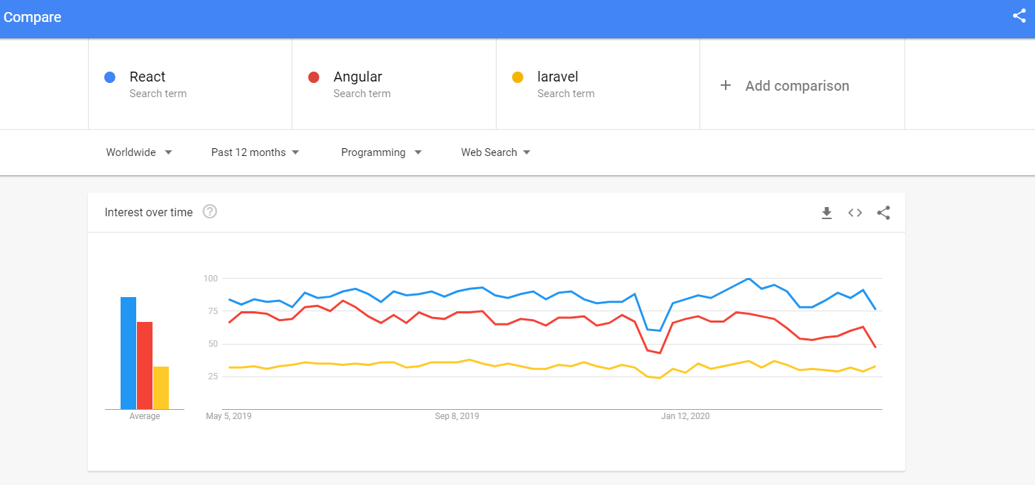

**Figure 4.2: Google Trends comparison result in the USA**

In React, many advantages stay along with their limitations. First of all, it will use a virtual DOM which is a JavaScript (JS) object and it will improve the performance of the apps since JavaScript (JS) virtual is faster than the regular DOM. To extend, it can be used on the client-side and server-side as well as another framework. Furthermore, component and data patterns improve readability which is helpful for the developer to maintain their large projects.

**5.3 Node Modules**

Node modules are the set of single or multiple JavaScript files that are used for giving functionality to any node.js application. React also uses this node module for giving functionality to any application. React already have some built-in node modules with it but I have used some extra modules for completing my project those are given below:

1. React-router-Dom: This module is very important for this react project. It helps to route data or components from one to other pages. Its work is to call data from the page.
2. Browser Router: I used a browser router for this project, and this browser router uses regular URL paths. For tracking router history, it uses the HTML5 History API. My project server needed to be configured correctly for better performance. My web server requires me to serve the same page URLs that are used by the client-side React Router.
3. React-bootstrap: React-bootstrap module is used for installing the most popular CSS framework bootstrap which is helping to develop a responsive and mobile-friendly design.
4. Link: Links are really important for my project used in react-router-dom. It helps the user to navigate elements between several pages of React apps.
5. Loadjs: This is used in the project for finding or fixing any bugs.

**5.4 The language used for Web Development**

I have used HTML5, CSS3, and JavaScript for the development of web applications.

**5.5 Editor: Visual Studio Code**

Visual Studio Code (VS Code) is a source code editorial manager created by Microsoft that can be run on Windows, macOS, and Linux. It is free, open-source, and offers help for investigating just as implicit Git variant control, linguistic structure features, scraps, etc. The UI of the VS Code is exceptionally adjustable, as clients can change to various subjects, console alternate ways, and inclinations.

**CHAPTER 6**

**DEVELOPMENT PROCESS**

**6.1 Project Design**

A good project plan and design makes any project a lot easier. Project design is an initial stage of the project. When I joined HashKode as an intern, my initial work was to rebuild an existing website by making it fast, dynamic, and responsive and it is tough. I worked day and night to accomplish this task by using React JS, a cutting-edge technology. In this section, we give full concern towards the use-case diagram of my internship project and that will be described in the portion of After completing that, we will give focus on the class diagram and represent it in section and Project functionalities in section, implementation in section. Database structure and Project Analysis in section.

**6.1.1 USE-CASE Diagram**

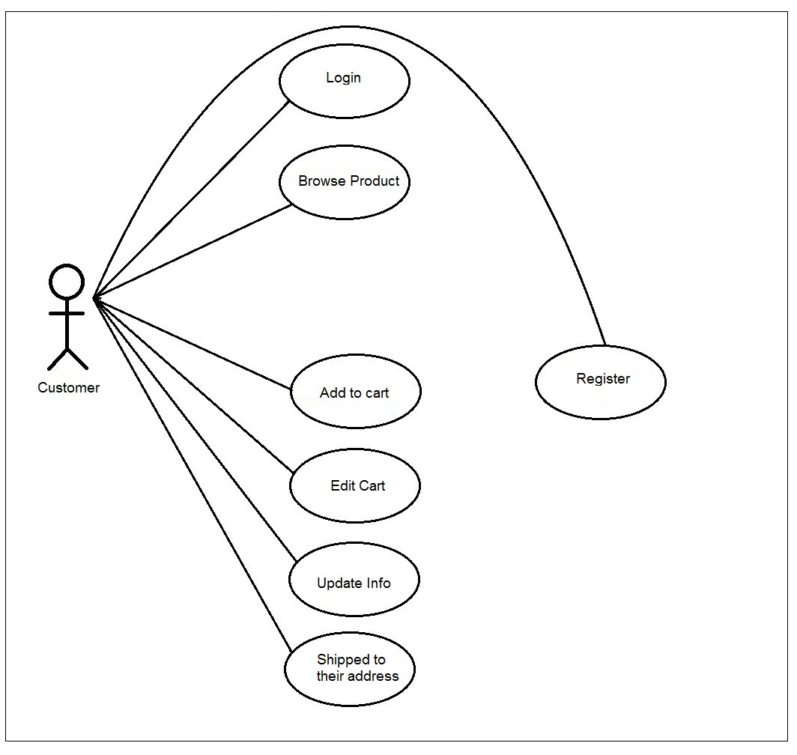

**Figure 6.1: Use Case diagram**

The Use Case Diagram given above shows a use case diagram is a graphic depiction of the interactions among the elements of a system. Use Case Diagram portrayed the system's functionality and necessity by using actors and use cases. It is represented by either circles or ellipses.

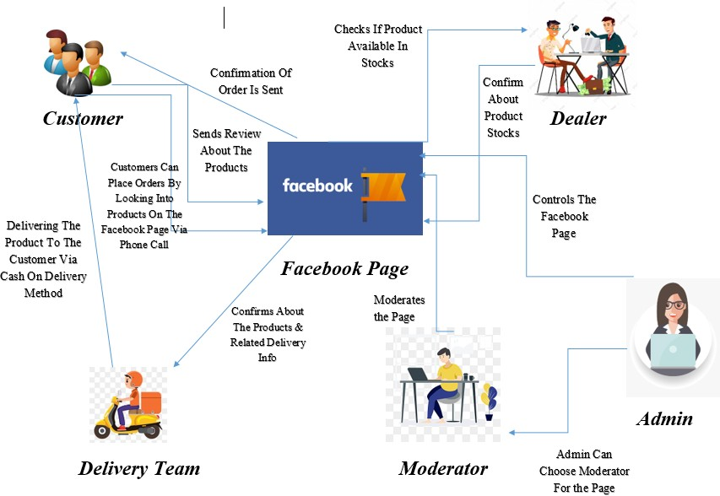**6.2 Rich Picture (Existing System)**

**Figure 6.2 Rich Picture of Existing System**

**6.2.1Rich Picture (Proposed System)**

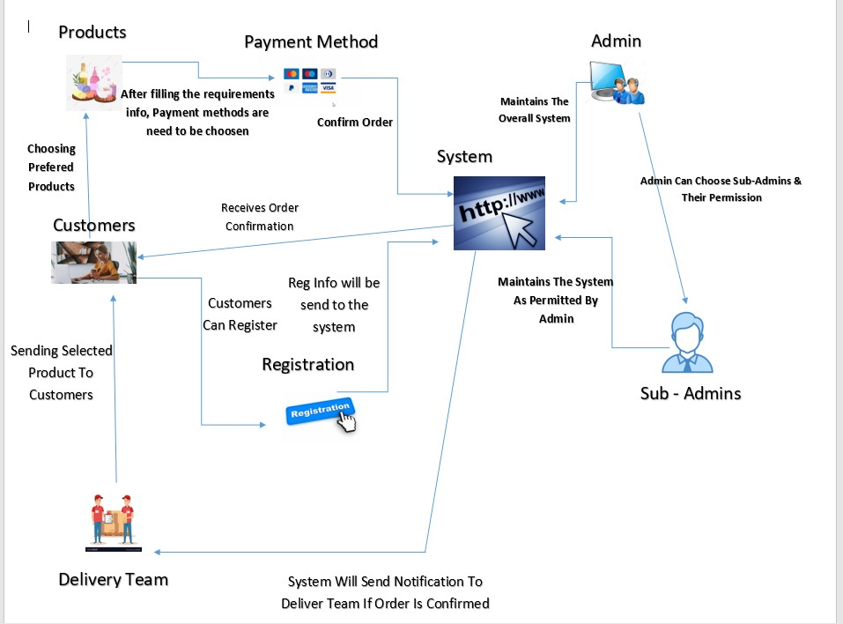

**Figure 6.2.1 Rich Picture of Proposed System**

**6.3 Class diagram**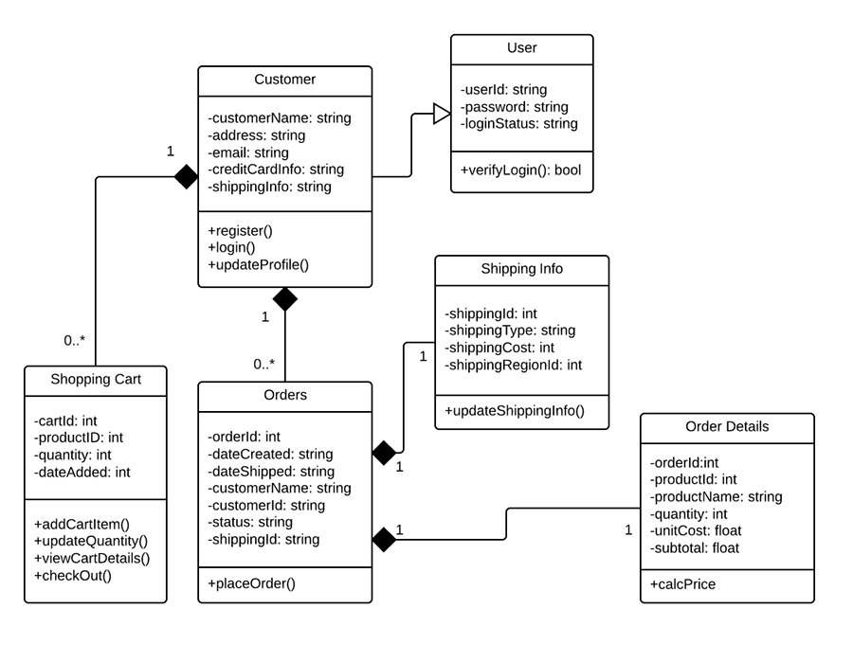

**Figure 6.3: Class diagram**

The class diagram is given above shows a class and the functions used in the project.

**6.4 Project functionalities**

1. A user can register as a new member.
2. An existing user can log in.
3. A user can view all products.
4. A user can search for products by category.
5. A user can add any product to the cart.
6. A user can place an order for shipping to his address.

**6.5 Data-Flow Diagram (DFD)**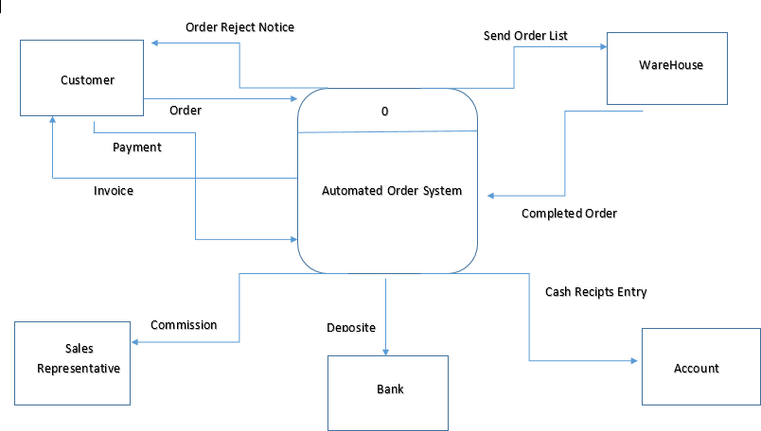

**Figure 5.5: DFD**

**6.6 PopUp Discount Offer**

1. A user can get offer
2. Sign up newsletter and get offer for purchases



Figure 6.6: PopUp

**6.7 Implementation**

Figure 6.7 shows the home page of this project which is divide into Ten-part the header the body Banner part, Latest Product part, All Product part, card part, Testimonial part, Blog part, News Letter part and the footer part.

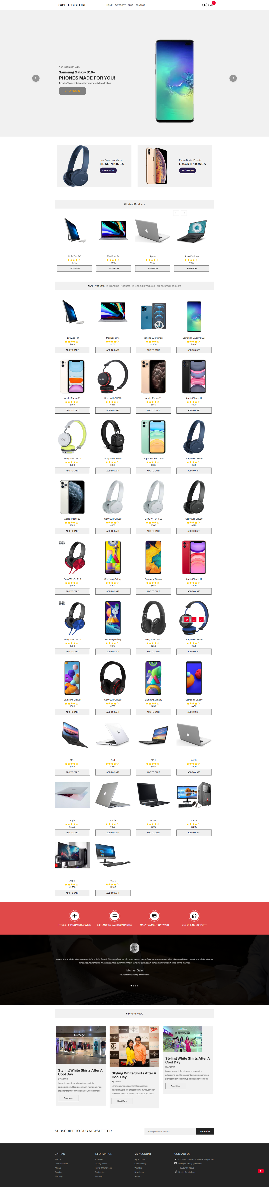

Figure 6.7: Home page

On the left side of the header part contains the logo of the company and the right side has a login and registration button which takes the user to the registration and the login page and card section. It also has a menu bar that contains the different product categories. After clicking any of them it will filter the products and give the user his desired result.



Figure 6.7: Header of the project

The body (Figure 5.5) contains the main part of the project which shows the list of all products to the user a user can easily find their expected product and if a user clicks on any product, he will get a detailed view of that particular product.

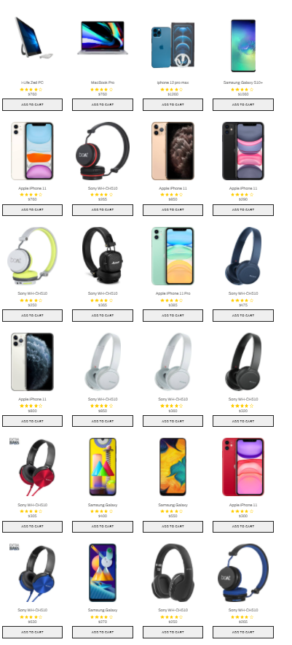

Figure 6.8: Body of the project

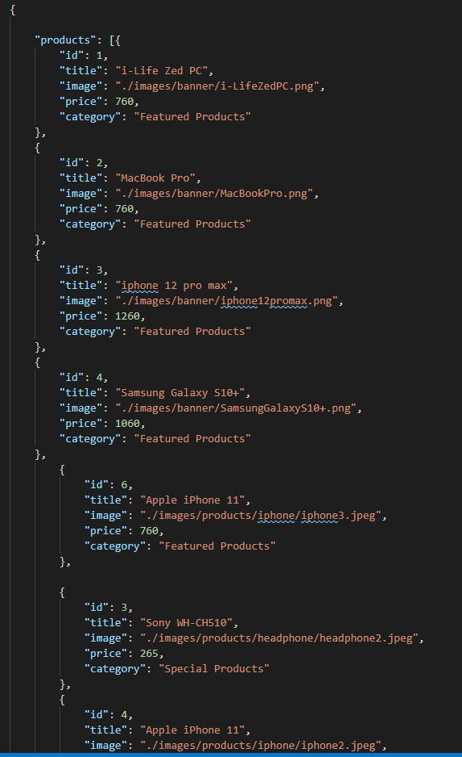For importing this product list into our body part, I have used a restful JSON API. Figure 4.6 shows the data in which the API returns from the product database.

Figure 6.8: JSON data

For implementing this data into our body part, I have made a get request to that API URL figure 4.7 shows the code for the get request.

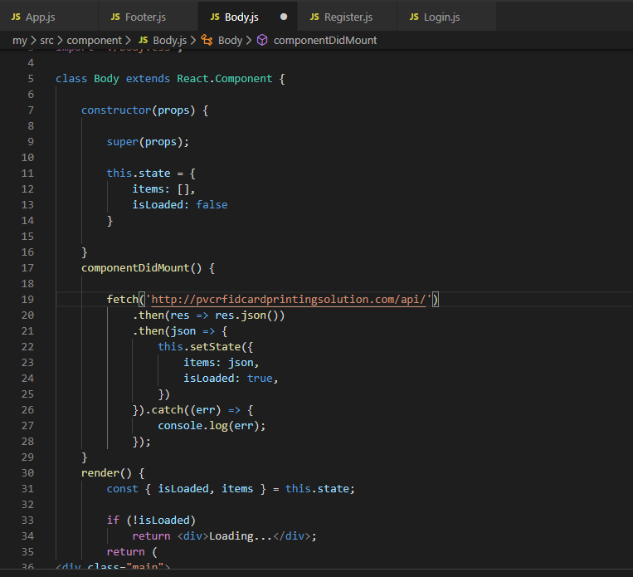

Figure 6.8: Code for API get request

The shipping and Testimonial part (Figure 6.9) part contains the shipping details, payment details etc, and the Testimonial part use client saying about our company

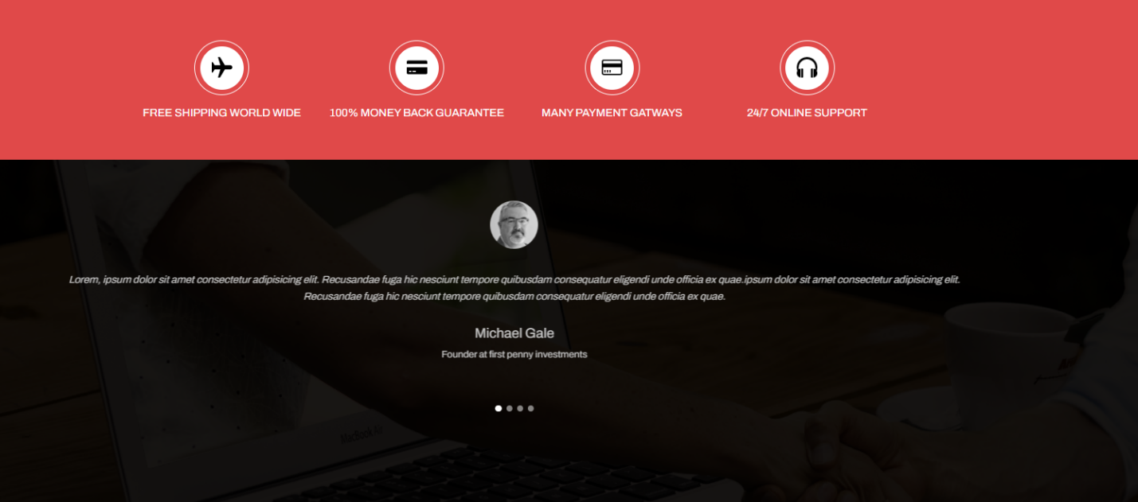

Figure 6.9: Testimonial part

The Blog use some picture our shop with some customer (Figure 6.10)

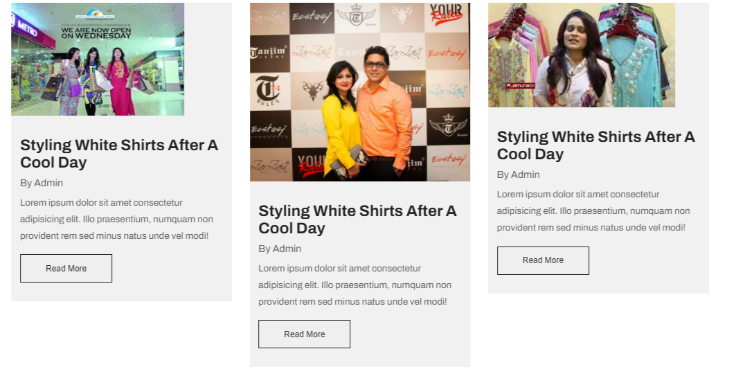

Figure 6.10: Blog

The footer section (6.11) here customer details, company details, Privacy and policy, Brand details contact details add.

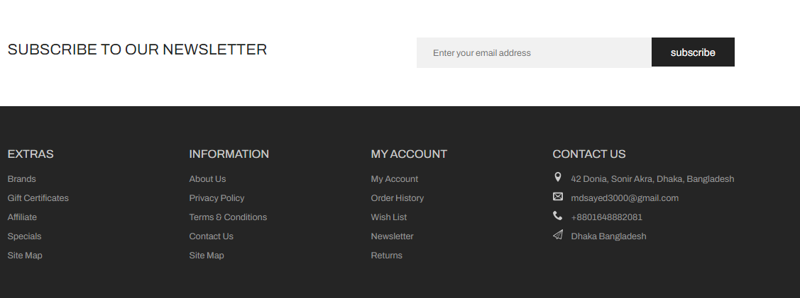

Figure 6.11: footer design

This is the complete code of the home page which contains all components of this project and where the react-router-dom module has used for routing data or components one to another.

const categoryCenter = document.querySelector(".category__center");

window.addEventListener("DOMContentLoaded", async function () {

  const products = await getProducts();

  displayProductItems(products);

});

const displayProductItems = items => {

  let displayProduct = items.map(

    product => `

                  <div class="product category__products">

                    <div class="product__header">

                      <img src=${product.image} alt="product">

                    </div>

                    <div class="product__footer">

                      <h3>${product.title}</h3>

                      <div class="rating">

                        <svg>

                          <use xlink:href="./images/sprite.svg#icon-star-full"></use>

                        </svg>

                        <svg>

                          <use xlink:href="./images/sprite.svg#icon-star-full"></use>

                        </svg>

                        <svg>

                          <use xlink:href="./images/sprite.svg#icon-star-full"></use>

                        </svg>

                        <svg>

                          <use xlink:href="./images/sprite.svg#icon-star-full"></use>

                        </svg>

                        <svg>

                          <use xlink:href="./images/sprite.svg#icon-star-empty"></use>

                        </svg>

                      </div>

                      <div class="product__price">

                        <h4>$${product.price}</h4>

                      </div>

                      <a href="http://127.0.0.1:5500/ecommerce_website/product.html#"><button type="submit" class="product__btn">Add to Cart</button></a>

                    </div>

                  <ul>

                      <li>

                        <a data-tip="Quick View" data-place="left" href="#">

                          <svg>

                            <use xlink:href="./images/sprite.svg#icon-eye"></use>

                          </svg>

                        </a>

                      </li>

                      <li>

                        <a data-tip="Add To Wishlist" data-place="left" href="#">

                          <svg>

                            <use xlink:href="./images/sprite.svg#icon-heart-o"></use>

                          </svg>

                        </a>

                      </li>

                      <li>

                        <a data-tip="Add To Compare" data-place="left" href="#">

                          <svg>

                            <use xlink:href="./images/sprite.svg#icon-loop2"></use>

                          </svg>

                        </a>

                      </li>

                  </ul>

                  </div>

                  `

  );

  displayProduct = displayProduct.join("");

  if (categoryCenter) {

    categoryCenter.innerHTML = displayProduct;

  }

};

const filterBtn = document.querySelectorAll(".filter-btn");

const categoryContainer = document.getElementById("category");

if (categoryContainer) {

  categoryContainer.addEventListener("click", async e => {

    const target = e.target.closest(".section__title");

    if (!target) return;

    const id = target.dataset.id;

    const products = await getProducts();

    if (id) {

      // remove active from buttons

      Array.from(filterBtn).forEach(btn => {

        btn.classList.remove("active");

      });

      target.classList.add("active");

      // Load Products

      let menuCategory = products.filter(product => {

        if (product.category === id) {

          return product;

        }

      });

      if (id === "All Products") {

        displayProductItems(products);

      } else {

        displayProductItems(menuCategory);

      }

    }

  });

}

/*

=============

Product Details Left

=============

 */

const pic1 = document.getElementById("pic1");

const pic2 = document.getElementById("pic2");

const pic3 = document.getElementById("pic3");

const pic4 = document.getElementById("pic4");

const pic5 = document.getElementById("pic5");

const picContainer = document.querySelector(".product__pictures");

const zoom = document.getElementById("zoom");

const pic = document.getElementById("pic");

// Picture List

const picList = [pic1, pic2, pic3, pic4, pic5];

// Active Picture

let picActive = 1;

["mouseover", "touchstart"].forEach(event => {

  if (picContainer) {

    picContainer.addEventListener(event, e => {

      const target = e.target.closest("img");

      if (!target) return;

      const id = target.id.slice(3);

      changeImage(`./images/products/iPhone/iphone${id}.jpeg`, id);

    });

  }

});

// change active image

const changeImage = (imgSrc, n) => {

  // change the main image

  pic.src = imgSrc;

  // change the background-image

  zoom.style.backgroundImage = `url(${imgSrc})`;

  //   remove the border from the previous active side image

  picList[picActive - 1].classList.remove("img-active");

  // add to the active image

  picList[n - 1].classList.add("img-active");

  //   update the active side picture

  picActive = n;

};

/*

=============

Product Details Bottom

=============

 */

const btns = document.querySelectorAll(".detail-btn");

const detail = document.querySelector(".product-detail__bottom");

const contents = document.querySelectorAll(".content");

if (detail) {

  detail.addEventListener("click", e => {

    const target = e.target.closest(".detail-btn");

    if (!target) return;

    const id = target.dataset.id;

    if (id) {

      Array.from(btns).forEach(btn => {

        // remove active from all btn

        btn.classList.remove("active");

        e.target.closest(".detail-btn").classList.add("active");

      });

      // hide other active

      Array.from(contents).forEach(content => {

        content.classList.remove("active");

      });

      const element = document.getElementById(id);

      element.classList.add("active");

    }

  });

}

Figure 6.12: Coding part

This product details page (Figure 6.13) contains a brief description & other specification of that particular product which is selected by the user from the home page body section and then the user can also add the product on the shopping cart page by clicking the add to cart button.

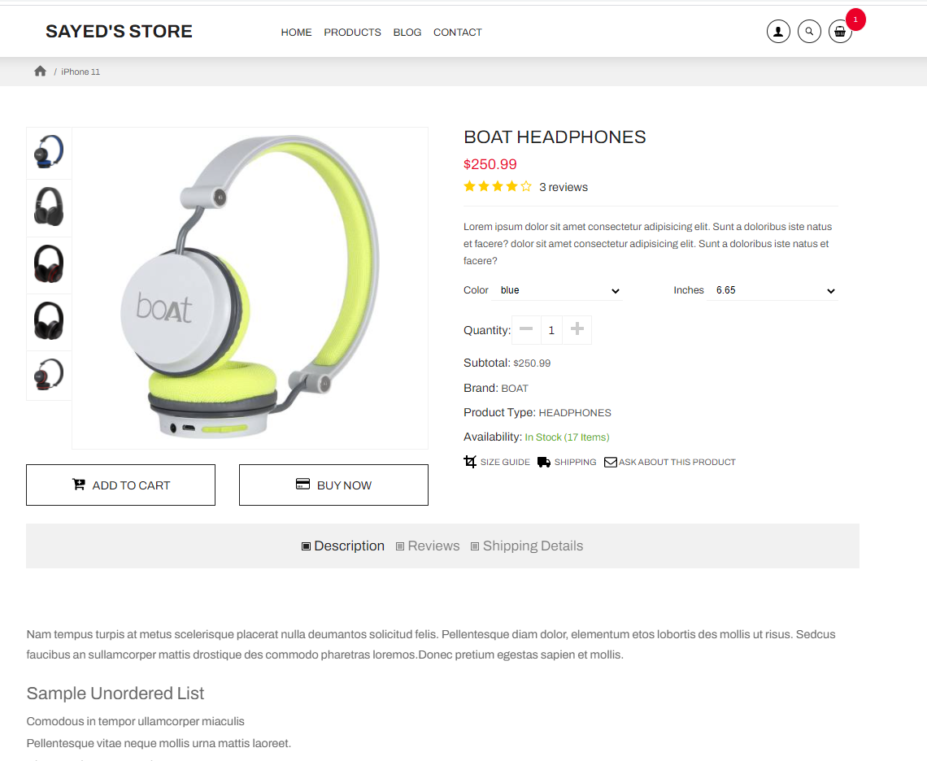

Figure 6.13: Coding part

This is the user registration page (Figure 6.14) of our project. If a user wants to become a member of the site, he just needs to fill out the form and hit the submit button after that he will become a registered member of this site.

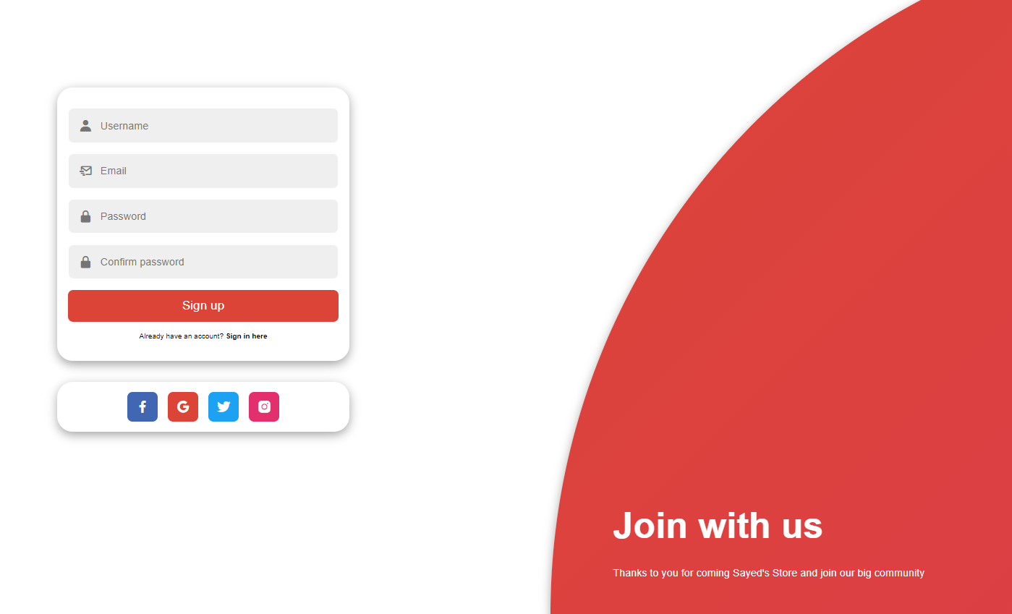

Figure 6.14: User registration page of the project.

A registered member can easily log in to this site for completing the checkout process by putting his login details into the user login form (Figure 6.15).

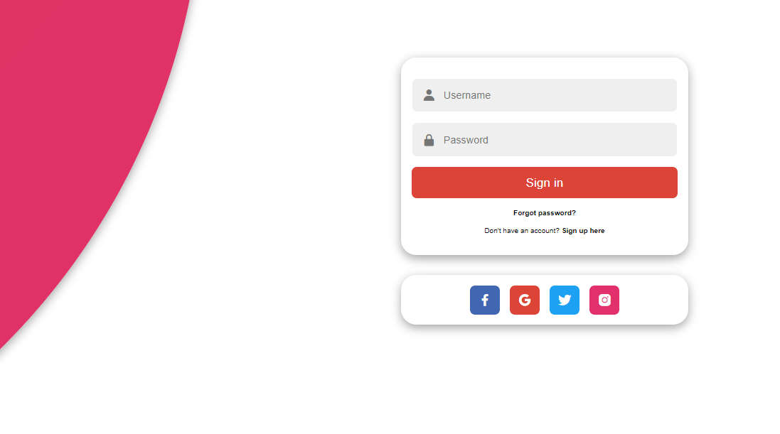

Figure 6.15: User login page of the project.

A registered member can easily Send and Email with Company if any problem (Figure 5.15).

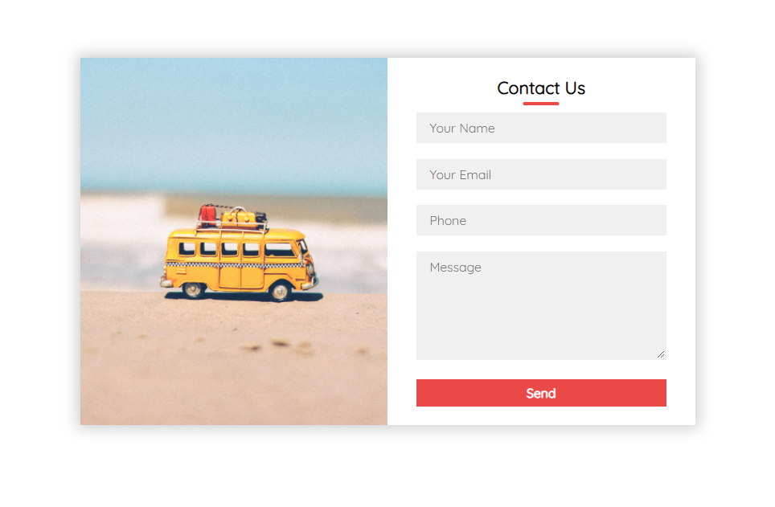

Figure 6.16: User login page of the project.

**6.17 Project Analysis**

I was offered for redeveloping and updating an eCommerce web application which is already developed by HashKode during my intern period. They have established a lot of web applications in the market but for the security and privacy reason they can’t provide me any larger project but they gave me the complete source code of Sayed’s Store which was developed with basic Html, JavaScript, CSS. My job was to convert the basic web application using React JS, and Node JS.

**Chapter 7**

**Future Work & Conclusion**

**7.1 Future Works**

Web-based application development is a crucial topic for an e-commerce site. People can browse, choose the products, and order towards the company, and the company will be delivered the product within a few days. We have a plan to change and bring a few changes to this website. Besides, we have another plan to add a few functionalities in this website which are given below:

1. Add the chatting system.
2. Have a launch android app.
3. Add an online payment system.
4. Make biggest Ecommerce like (Ebay)
5. Secure customer date no hacking chance
6. Many more

**7.2 Conclusion**

Working with HashKode an intern has helped me to understand what is my area of interest. I have gained an immense amount of technical knowledge from this work experience and I plan to continue it for my future career. I believe that my commitment as a web application developer won't solely enhance my career path however additionally I have to learn new technologies to improve my ability to create changes on my career path.

To extend, as an intern, I have learned React JS for web application development, and to code in a way that my code can be easily changeable, reusable, and easy to fix bugs and profitable and a new programmer can use it after. I used to React JS for my internship project development and while working with React JS, I found it easily learnable, usable, and there is a bright scope for me to choose to React development as a future path.

Also, I set myself some achievement list before the beginning of my internship for my improvement and I am pleased to inform that my achievement list was achieved precisely. On the other hand, I have learned to acclimate to work in a development team and also in a professional environment. As a web developer, I gain so much confidence dramatically due to my internship. I am ready to work in a professional organization and eager to contribute to growth and profit with all the skills I have acquired.

**Reference**

* + 1. Visual Studio Code - Code Editing. Redefined, "Docs, Getting Started”

Available: https://code.visualstudio.com/. [Accessed: 1-May-2021].

* + 1. Software Testing Materials, "Software Testing Definition, Types”

Available: <https://www.softwaretestingmaterial.com/software-testing/>.

[Accessed: 1-May-2021].

* + 1. w3.org. [Online]

Available <https://www.w3.org/standards/webdesign/htmlcss>. [Accessed: 1-May-2021].

* + 1. React Tutorial [Online],

Available: <https://www.w3schools.com/REACT/default.asp>. [Accessed: 1-May-2021].

* + 1. JavaScript Tutorial [Online]

Available: <https://www.w3schools.com/js/default.asp>. [Accessed: 1-May-2021].

* + 1. CSS Tutorial [Online],

Available: <https://www.w3schools.com/css/default.asp> [Accessed: 1-May-2021].

* + 1. HTML Tutorial [Online],

Available: <https://www.w3schools.com/html/default.asp> [Accessed: 1-May-2021].

* + 1. Primary Components [Online]

Available: <https://reacttraining.com/react-router/web/guides/primary-components>. [Accessed: 1-May-2021].

* + 1. API [Online]

Available: https://jsonplaceholder.typicode.com/. [Accessed: 1-May-2021].

* + 1. GITHUB [Online]

Available: https://github.com/ .[Accessed: 1-May-2021].